**22nd Northwest Algal Symposium**

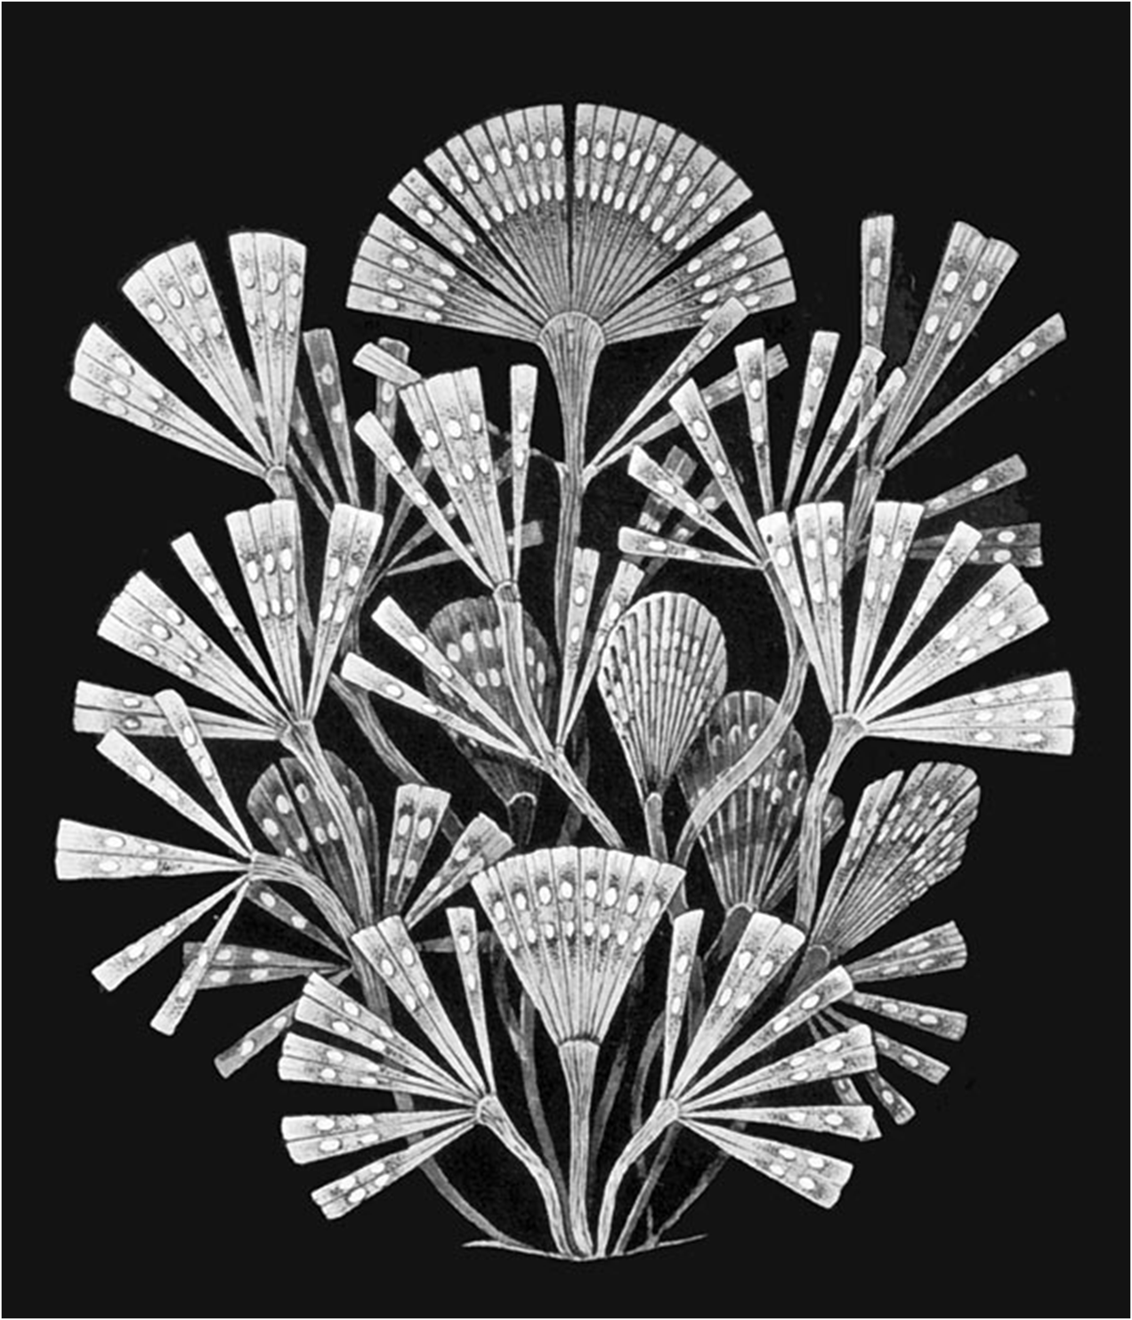

**Charleston, Oregon**

**4-6 April 2008**

**22nd Northwest Algal Symposium**

**A forum for those with an interest in algae.**

**Oregon Institute of Marine Biology, Charleston, Oregon**

**4-6 April 2008**

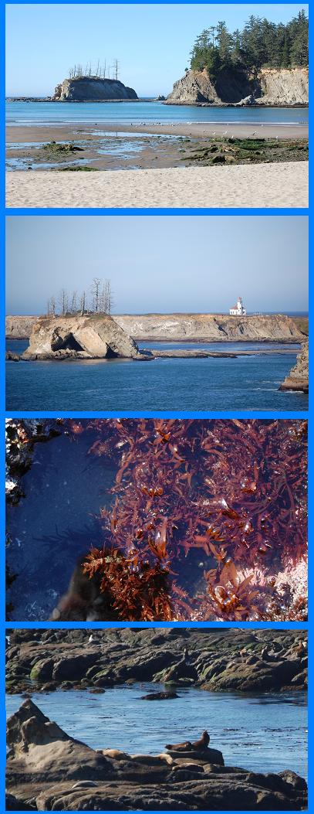

**Convener: Tim O’Higgins**

**Organizing Committee:** Tim O’Higgins, Gayle Hansen, Linda O’Higgins

**Additional Help**: Deral McKeel, Tim Nelson, June Mohler, Shirley Pedro and Giesele Muller-Parker

**Catering:** Premier Services, Coos Bay, and OIMB Kitchen Staff, Charleston

**PROGRAM**

**Friday, April 4**

03:00-07:00 pm (Dining Hall). Registration

07:00-10:00 pm (Dining Hall) Poster Presentations and Mixer

**Posters:**

1. **Willapa Bay: A True Hotspot for Seaweed and Seagrass Introductions on the U. S. West Coast.** *Gayle I. Hansen, Oregon State University, Newport, OR*
2. **A New Genus and Species from the Aleutians May Provide the Key to Kelp Evolution.**  Mandy R. Lindeberg1, Hiroshi Kawai2, Takeaki Hanyuda2, and Sandra C. Lindstrom3. *1 NOAA Auke Bay Laboratories, Auke Bay, AK, 2 Kobe University Research Center for Inland Seas, Kobe, Japan, 3University of British Columbia, Vancouver, BC*
3. **Macroalgal Changes within the Marine Community in Kachemak Bay, Alaska since 1976.**  *Melissa Deiman, University of Alaska Fairbanks, AK*
4. **Comparing Kelp Communities on the Inner and Outer Coasts of Southeast Alaska.** *Sonia N. Ibarra1, Jodi. L. Pirtle2, and Ginny Eckert1, 2. 1University of Alaska-Southeast, Juneau, AK, 2University of Alaska Fairbanks, Juneau, AK*
5. **Resource Allocation in Sugar Kelp, *Saccharina latissima*, under Varying Environmental Conditions in Kachemak Bay, Alaska.** *Tania Spurkland1 & Katrin Iken1, and Kwang Young Kim2. 1University of Alaska, Fairbanks, AK, and 2Chonnam National University, Korea*
6. **Advances in Understanding, Predicting, and Tracking Oregon Harmful Algal Blooms**. *Strutton, P. G., Oregon State University, Corvallis, OR. Wood, A. M., University of Oregon, Eugene, OR. Tweddle, J. F., Oregon State University, Corvallis, OR. Cannon, D., Oregon Department of Agriculture, Salem, OR. Hunter, M., Oregon Dapartment of Fish and Wildlife, Astoria, OR. Foley, D., NOAA CoastWatch, Pacific Grove, CA. Scott, B., University of Oregon, Eugene, OR*
7. **The Relationship between Coastal Ocean Dynamics and Shellfish Closures: A Satellite Based Study of Oregon HABS*.*** *J.F. Tweddle1, P. Strutton1, M. Wood2, D. Foley3, M. Hunter**4, Z. Forster4 and Deb Cannon5.  1College of Oceanic and Atmospheric Sciences, Oregon State University; 2Department of Biology, University of Oregon; 3NOAA Coastwatch; 4Oregon Department of Fish and Wildlife; and 5Oregon Department of Agriculture*
8. **Molecular Monitoring and Detection of the Toxic Dinoflagellate *Alexandrium catenella* in Puget Sound.** *Nicole Kollars1, 2, Sheean Haley3, Deana Erdner4, and Sonya Dyhrman3.. 1Boston University Marine Program REU, 2Western Washington University, 3Woods Hole Oceanographic Institution, and 4University of Texas Marine Science Institute.*
9. **Photoacclimation of a Neurotoxigenic Diatom, *Pseudo-nitzschia multiseries*.** *Ken Hamel, Andy Wong, & Micaela S. Parker. University of Washington, Seattle, WA*
10. **How does Exposure to High Temperature and Light affect Asexual Reproduction of the Tropical Sea Anemone *Aiptasia pallida*?** *Whitney Gray and Gisele Muller- Parker, Western Washington University, Bellingham, WA*
11. **Profile of the CICORE and CENCOOS Nearshore Ocean Observation Platform in Humboldt County, CA.** *Frank Shaughnessy, Greg Crawford, Steve Steinberg, Jose Montoya, Mike Gough. Humboldt State University, Arcata, CA*
12. **Concurrent Detection of the Pacific Decadal Oscillation in Multiple Estuaries: Ocean Estuary Coupling in Padilla Bay (WA), South Slough (OR), and Elkhorn Slough (CA) National Estuarine Research Reserves.** *Tim O’Higgins1, Steven Rumrill2, Alicia Helms2, and Adam DeMarzo2. 1 NRC at WED/PCEB, U. S. Environmental Protection Agency, Newport, OR and  2South Slough National Estuarine Research Reserve, Charleston, OR*

**Saturday, April 5**

07:00-08:00 am (Dining Hall) Breakfast

08:20-08:30 am (Boathouse) Welcome – Tim O’Higgins

08:30-11:30 am (Boathouse) Oral Presentations

**Session 1 --**

08:30 am **Macroecological perspectives of NE Pacific primary producers: an objective provincial approach.** *Maria T. Kavanaugh. Oregon State University, Corvallis, OR*

08:45 am **Ten years of rocky intertidal community dynamics in a Humboldt Bay site and its relationship to climate change.** *Susan Sebring, Angela Gallardo, and Benhamish Allen. Humboldt State University, Arcata, CA*

09:00 am **Redefining the Ricketts intertidal community structure model for a site in Humboldt Bay, California.**  *Sarah Wood, Annie Hanks, and Bethany Baibak. Humboldt State University, Arcata, CA*

09:15 am **A spatial model of potential eelgrass (*Zostera marina*) habitat in Humboldt Bay, CA** *Whelan A.Gilkerson, Steven J. Steinberg, Frank J. Shaughnessy, and Greg B. Crawford. Humboldt State University, Arcata, CA*

09:30 am **How does macroalgae affect eelgrass (*Zostera marina*) density along an upwelling- influenced estuarine gradient?** *Margot Hessing-Lewis1, Sally Hacker1, Bruce Menge1, and Steve Rumrill2. 1Oregon State University, Corvallis, OR, and 2South Slough Estuarine Research Reserve, Charleston, OR*

09:45-10:15 am (Boathouse Entry) Coffee/Tea Break

**Session 2 –**

10:15 am **Preliminary description of phytoplankton dynamics from a long term monitoring site in Humboldt Bay, California**. *Gregory O’Connell & Frank Shaughnessy.  Humboldt State University, Arcata, CA*

10:30 am **Ocean motion: micro-scale tracking of swimming algae.**  *Michael T. Nishizaki, Rose Ann Cattolico & Daniel Grunbaum. University of Washington, Seattle, WA*

10:45 am **Two-stage bioreactor culture of the pennate diatom *Pinnularia* for the fabrication of a TIO2-based solar cell.** *Clayton Jeffreyes1, Timothy Gutu2, Jun Jiao2, Chih-hung Chang1, Mark E. Jones, and Gregory L. Rorrer 1. 1Oregon State University, Corvallis, OR, 2Portland State University, Portland, OR, 3US-DOE Pacific Northwest National Laboratory, Richland, WA*

11:00 am **The effects of size and shape on diatom (*Coscinodiscus*) sinking**. *Kevin A. Miklasz. Hopkins Marine Station, Stanford University, Monterey, CA*

11:15 am **Biosensor platform development using antibody-functionalized diatom frustules.** *Debra K. Gale1, Timothy Gutu2, Jun Jiao2, Chih-hung Chang1, and Gregory L. Rorrer1. 1Oregon State University, Corvallis, OR, and 2Portland State University, Portland, OR*

12:00 noon -01:00 pm (Dining Hall) Lunch

01:30-04:30 pm (Boathouse) Oral Presentations

**Session 3 --**

01:30 pm **A century of *Ceramium* sampled: the role of herbarium specimens**. *Amy L. Carlile, J. Robert Waaland, and Benjamin D. Hall. University of Washington, Seattle, WA*

01:45 pm **Recruitment strategies of the ephemeral opportunistic macroalga *Ulva* (Linnaeus) in central California**. *Rosemary Romero.* *Moss Landing Marine laboratories, CA*

02:00 pm **Genetic variation and cryptic diversity in northeast Pacific species of *Porphyra sensu lato* (Bangiales, Rhodophyta).** *Sandra Lindstrom. University of British Columbia, Vancouver, BC, Canada.*

02:15 pm **Regional comparisons of *Codium* (Chlorophyta, Bryopsidales) assemblages in the northern vs. southern English Channel**. *Cynthia D. Trowbridge and William F. Farnham. Oregon State University, Newport, OR, and University of Portsmouth, Eastney, Portsmouth, UK*

02:30 pm **Marine algae of Steamboat Island, Washington, forty years on: 1967 and 2007 compared**. *Thomas F. Mumford, Jr.1 and J. Robert Waaland2. 1Washington Department of Natural Resources, Olympia, WA, and 2University of Washington, Seattle, WA*

02:45-3:15 pm (Boathouse Entry) Coffee/Tea Break

**Session 4 --**

03:15 pm **Incipient report of domoic acid production by four benthic diatom species under nonaxenic batch culture conditions.** *Linda O’Higgins, Oregon State University, Hatfield Marine Science Center, Newport, OR*

03:30 pm **Biological fabrication of photoluminescent nanocomb structures by cell culture of the diatom *Nitzschia frustulum*.**  *Tian Qin1, Timothy Gutu2, Jun Jiao2, Chih-hung Chang1, and Gregory L. Rorrer1. 1Oregon State University, Corvallis, OR, and 2Portland State University, Portland, OR*

03:45 pm **Temporal and vertical distribution of *Euglena* spp. in beach sand.** *Michael B. Kingston and Jennifer Gough. Elon University, Elon, NC*

04:00 pm ***Sinosiphonia elegans*, new to North America**. *Gayle I. Hansen, Oregon State University, Newport, OR*

04:15-04:45 pm (Boathouse) **Business Meeting -- open to all.**

**Evening Events --**

06:00–07:00 pm (Dining Hall) Mixer

07:00–08:00 pm. (Dining Hall). Banquet

08:00–09:00 pm (Dining Hall). Special After Banquet Talk.

**The Arctic Ocean: Early Explorations, Recent Studies of Algal Production, and the Disappearance of the Arctic Ice Cap.** Patricia A. Wheeler, Distinguished Professor, College of Oceanic and Atmospheric Sciences, Oregon State University, Corvallis, OR

09:00 pm on – Awards and Auction

**Sunday, April 6**

06:30–08:00 am (Sunset Bay Field Trip)

Leave from Dining Hall Parking Lot at 06:30 am. Take private cars to Sunset Bay for intertidaling and phytoplankton tows. Wear raingear and boots. We have an OPRD permit for small collections from Sunset Bay.

08:00–9:00 am (Lab across from the Dining Hall) Collection Processing.

Examining and identifying phytoplankton. Sorting, identifying, and pressing macroalgae.

Several microscopes and slides and coverslips will be provided.

09:00–10:00 am (Dining Hall) Breakfast

10:00–11:15 am (Boathouse) Oral Presentations

**Session 5 --**

10:00 am **Evolution and diversity of marine picocyanobacteria.** *Wood, A. M.1 and R. C. Everroad1,2. 1University of Oregon, Eugene, Oregon, USA, and 2Tokyo Metropolitan University, Tokyo, Japan*

10:15 am **Specialist herbivores on filamentous red algae.** *Cynthia D. Trowbridge, Yoshiaki J. Hirano, and Yayoi M. Hirano. Oregon State University, Newport, OR, and Marine Biosystems Research Center, Chiba University, Japan*

10:30 am **Experimental transplant of a small eelgrass bed (*Zostera marina*) within the north fork of the Siuslaw River Estuary, Oregon.** *Steven S. Rumrill. South Slough National Estuarine Research Reserve, Charleston, OR 97420*

10:45 am **Positive effects of Brant geese grazing on eelgrass productivity in Humboldt Bay, CA.** *Susannah Ferson1, Frank Shaughnessy1, Adam Frimodig2, Jeffrey Black1. 1Humboldt State University, Arcata, CA, and the 2CA Department of Fish & Game, Eureka, CA*

11:00 am **Ecosystem services of algae in estuaries of the west coast of North America: the almighty dollar.** *Tim O’Higgins, NRC at WED/PCEB, US Environmental Protection Agency, Newport, OR*

11:15–12:00 Noon. Meeting End. Coffee/Tea Break and Checkout

**Monday, April 7**

06:30–10:00 am. **South Cove Field trip**

Meet at parking lot outside Dining Hall at 6:30 am. Take private cars to South Cove trail.

We have an OPRD Seaweed Collecting Permit for small collections at South Cove.

Take collections home for sorting and processing.

**Have a safe trip home!**

ABSTRACTS

(alaphabetically by first author. –s denotes student)



22nd NWAS Participant Information

|  |  |  |
| --- | --- | --- |
| **Last Name** | **Affiliation** | **E-mail** |
| **Allen, Benhamish** | Humboldt State University, Arcata, CA | [bwa2@humboldt.edu](mailto:bwa2@humboldt.edu) |
| **Baglot, Kim** | Simon Fraser Unversity, Burnaby, BC | [kbaglot@gmail.com](mailto:kbaglot@gmail.com) |
| **Baibak, Bethany** | Humboldt State University, Arcata, CA | [b4baibak@yahoo.com](mailto:b4baibak@yahoo.com) |
| **Bilderback, Dave** | Bandon, OR | [dbilderback@mycomspan.com](mailto:dbilderback@mycomspan.com) |
| **Burgess, Amy** | Shannon Point Marine Center, Anacortes, WA | [amykeita@gmail.com](mailto:amykeita@gmail.com) |
| **Carlile, Amy** | University of Washington, Seattle, WA | [acarlile@u.washington.edu](mailto:acarlisle@u.washington.edu) |
| **Deiman, Melissa** | University of Alaska, Fairbanks, AK | [fsmrd5@uaf.edu](mailto:fsmrd5@uaf.edu) |
| **Duffield, Ellie** | University of Washington, Seattle, WA | [ecsd@u.washington.edu](mailto:ecsd@u.washington.edu) |
| **Dyck, Leonard** | University of British Columbia, Vancouver, BC | [ldyc@interchange.ubc.ca](mailto:ldyc@interchange.ubc.ca) |
| **Eskandari, P** | Humboldt State University, Arcata, CA | [pge3@humboldt.edu](mailto:pge3@humboldt.edu) |
| **Fairham-Wheeler, Kevin** | Milwaukie, OR | [wheelerk@spiritone.com](mailto:wheelerk@spiritone.com) |
| **Fitch, Rob** | Wenatchee Valley College, Wenatchee, WA | [rfitch@wuc.edu](mailto:rfitch@wuc.edu) |
| **Fletcher, Melissa** | Humboldt State University, Arcata, CA | [melissa_sueanne@hotmail.com](mailto:melissa_sueanne@hotmail.com) |
| **Forster, Zach** | Oregon Department of Fish and Wildlife, Astoria, OR | [zachary.r.forster@state.or.us](mailto:zachary.r.forster@state.or.us) |
| **Gale, Debra** | Oregon State University, Corvallis, OR | [galede@engr.orst.edu](mailto:galede@engr.orst.edu) |
| **Gallardo, Angela** | Humboldt State University, Arcata, CA | [ajg27@humboldt.edu](mailto:ajg27@humboldt.edu) |
| **Gilkerson, Whelan** | Humboldt State University, Arcata, CA | [whelangilk@yahoo.com](mailto:whelangilk@yahoo.com) |
| **Gray, Whitney** | Western Washington University, Bellingham, WA | [w_gray86@yahoo.com](mailto:w_gray86@yahoo.com) |
| **Guerra, Carmen** | Western Washington University, Bellingham, WA | [guerracz@cc.wwu.edu](mailto:guerracz@cc.wwu.edu) |
| **Hamel, Ken** | University of Washington, Seattle, WA | [khamel@u.washington.edu](mailto:khamel@u.washington.edu) |
| **Hamlin, Samantha** | Western Washington University, Bellingham, WA | [hamlins@cc.wwu.edu](mailto:hamlins@cc.wwu.edu) |
| **Hanks, Annie** | Humboldt State University, Arcata, CA | [ah54@humboldt.edu](mailto:ah54@humboldt.edu) |
| **Hansen, Gayle** | Oregon State University, Newport, OR | [hansen.gayle@epa.gov](mailto:hansen.gayle@epa.gov) |
| **Harlin, Marilyn** | University of Rhode Island & Portland, OR | [mharlin@macforcego.com](mailto:mharlin@macforcego.com) |
| **Hawkes, Mike** | University of British Columbia, Vancouver, BC | [mhawkes@interchange.ubc.ca](mailto:mhawkes@interchange.ubc.ca) |
| **Hessing-Lewis, Margot** | Oregon State University, Corvallis, OR | [hessingm@science.edu](mailto:hessingm@science.edu) |
| **Hiebert, Laurel** | University of Oregon, Eugene, OR | [lhiebert@uoregon.edu](mailto:lhiebert@uoregon.edu) |
| **Hondelero, Dominic** | University of Alaska, Fairbanks, AK | [fsdeh9@uaf.edu](mailto:fsdeh9@uaf.edu) |
| **Ibarra, Sonia** | Humboldt State University, Arcata, CA | [sn.ibarra@hotmail.com](mailto:sn.ibarra@hotmail.com) |
| **Jeffreyes, Clayton** | Oregon State University, Corvallis, OR | [jeffryes@engr.orst.edu](mailto:jeffryes@engr.orst.edu) |
| **Kavanaugh, Maria** | Oregon State University, Corvallis, OR | [mkavanau@coas.oregonstate.edu](mailto:mkavanau@coas.oregonstate.edu) |
| **Kingston, Mike** | Elon University, Elon, NC | [kingston@elon.edu](mailto:kingston@elon.edu) |
| **Kollars, Nicole** | Western Washington University, Bellingham, WA | [nmkollars@gmail.com](mailto:nmkollars@gmail.com) |
| **Lenne, Mike** | Western Washington University, Bellingham, WA | [mrlennevt@gmail.com](mailto:mrlennevt@gmail.com) |
| **Lindstrom, Sandra** | University of British Columbia, Vancouver, BC | [sandracl@interchange.ubc.ca](mailto:sandracl@interchange.ubc.ca) |
| **McConnaughey, Evelyn** | Eugene, OR | [evelynm@efn.org](mailto:evelynm@efn.org) |
| **McConnaughey, Ted** | Boise, ID | [mcconnat@gmail.com](mailto:mcconnat@gmail.com) |
| **McKeel, Deral** | Newport, OR | [dgmckeel@mac.com](mailto:dgmckeel@mac.com) |
| **Meier, Whitney** | Humboldt State University, Arcata, CA | [wmm3@humboldt.edu](mailto:wmm3@humboldt.edu) |
| **Miklasz, Kevin** | Hopkins Marine Station, Pacific Grove, CA | [kmiklasz@stanford.edu](mailto:kmiklasz@stanford.edu) |
| **Mohler, June** | Portland State University, Portland, OR | [pterygophora@earthlink.net](mailto:pterygophora@earthlink.net) |
| **Muller-Parker, Gisele** | Shannon Point Marine Center, Anacortes, WA | [gisele.muller-parker@wwu.edu](mailto:gisele.muller-parker@wwu.edu) |
| **Mumford, Tom** | Washington Department of Natural Resources, Olympia, WA | [tom.mumford@dnr.wa.gov](mailto:tom.mumford@dnr.wa.gov) |
| **Nishizaki, Mike** | University of Washington, Seattle, WA | [mikenish@u.washington.edu](mailto:mikenish@u.washington.edu) |
| **O'Connell, Greg** | Humboldt State University, Arcata, CA | [gdo2@humboldt.edu](mailto:gdo2@humboldt.edu) |
| **O'Higgins, Linda** | Oregon State University at NOAA, Newport, OR | [ohiggins.linda@noaa.gov](mailto:ohiggins.linda@noaa.gov) |
| **O'Higgins, Tim** | NRC at EPA, Newport, OR | [ohiggins.tim@epa.gov](mailto:ohiggins.tim@epa.gov) |
| **Poole, Allison** | University of Oregon, Eugene, OR | [apoole4@uoregon.edu](mailto:apoole4@uoregon.edu) |
| **Romero, Rosemary** | Moss Landing Marine Labs, Moss Landing, CA | [rromero@mlml.calstate.edu](mailto:rromero@mlml.calstate.edu) |
| **Rorrer, Greg** | Oregon State University, Corvallis, OR | [rorrergl@engr.orst.edu](mailto:rorrergl@engr.orst.edu) |
| **Rumrill, Steve** | South Slough NERR, Charleston, OR | [steve.rumrill@state.or.us](mailto:steve.rumrill@state.or.us) |
| **Sampson, Jessica** | Simon Fraser Unversity, Burnaby, BC | [jlsampson@sfu.ca](mailto:jlsampson@sfu.ca) |
| **Sardelich, Andrew** | Humboldt State University, Arcata, CA | [APS7@humboldt.edu](mailto:APS7@humboldt.edu) |
| **Sebring, Susan** | Humboldt State University, Arcata, CA | [svs8@humboldt.edu](mailto:svs8@humboldt.edu) |
| **Shaughnessy, Frank** | Humboldt State University, Arcata, CA | [fjs3@humboldt.edu](mailto:fjs3@humboldt.edu) |
| **Simonson, Erika** | Simon Fraser Unversity, Burnaby, BC | [esimonso@sfu.ca](mailto:esimonso@sfu.ca) |
| **Spurkland, Tania** | University of Alaska, Fairbanks, AK | [tspurk@sfos.naf.edu](mailto:tspurk@sfos.naf.edu) |
| **Spurkland, Tobben** | University of Alaska, Fairbanks, AK | [klippfisk@msn.com](mailto:klippfisk@msn.com) |
| **Trowbridge, Cynthia** | Oregon State University, Newport, OR | [trowbric@yahoo.com](mailto:trowbric@yahoo.com) |
| **Tweddle, Jacqui** | Oregon State University, Corvallis, OR | [jtweddle@coas.oregonstate.edu](mailto:jtweddle@coas.oregonstate.edu) |
| **Waaland, Bob** | University of Washington, Seattle, WA | [jrw@u.washington.edu](mailto:jrw@u.washington.edu) |
| **Watts, Cassy** | Humboldt State University, Arcata, CA | [cmw30@humboldt.edu](mailto:cmw30@humboldt.edu) |
| **Wheeler, Pat** | Oregon State University, Corvallis, OR | [pwheeler@coas.oregonstate.edu](mailto:pwheeler@coas.oregonstate.edu) |
| **Wilcox, Whitney** | Humboldt State University, Arcata, CA | [monkey.petey@gmail.com](mailto:monkey.petey@gmail.com) |
| **Wood, Sarah** | Humboldt State University, Arcata | [sgw7@humboldt.edu](mailto:sgw7@humboldt.edu) |
| **Wood, Michelle** | University of Oregon, Eugene, OR | [miche@uoregon.edu](mailto:miche@uoregon.edu) |
| **Young, Craig** | OIMB, Charleston, OR | [cmyoung@uoregon.edu](mailto:cmyoung@uoregon.edu) |