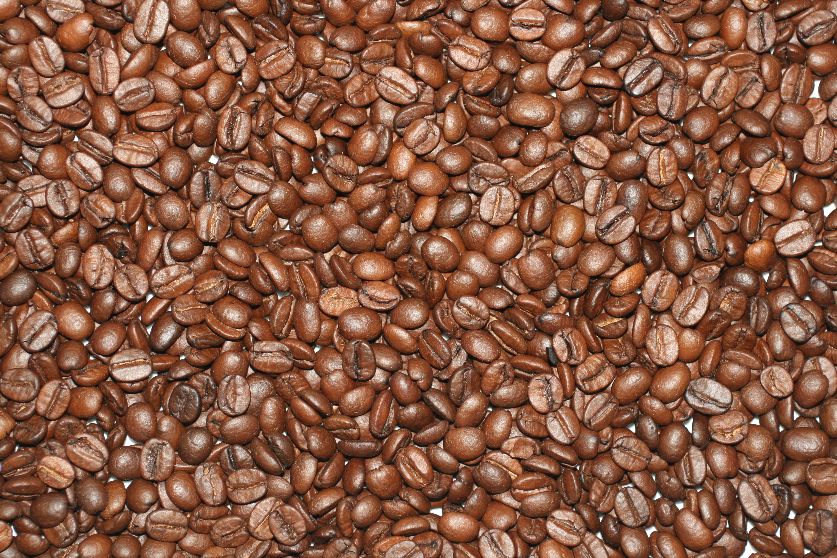

Thank you so much for bringing your own coffee mug today to use! We hope that this is one small example of a way in which you and your worshipping community can reduce waste and encourage community.
A cup…
t…

Ceramic mugs and glassware are better alternatives to Styrofoam for holding hot and cold beverages at congregational events and Sunday fellowship. Just think if 100 people came to church and used a single Styrofoam cup during fellowship each Sunday throughout the year, they would use and toss away enough cups to fill (15) 32 gallon trash cans. Multiply this by the millions of congregations in the United States alone. This seemingly insignificant piece of trash, when added to all the other waste we generate, does not create a healthy environment for our children or grandchildren to inherit.
Not to mention, we strive to make our coffee hours ones in which we are grounded in community with one another. Imagine the sense of holding a Styrofoam cup in hand vs. a smooth, rounded ceramic mug from the random assortment of a fellow member. The throw away version seems flimsy and itinerant, while the latter seems to ground one in the moment and in that particular community of worship.
Why not encourage every member of your congregation to donate 2-3 mugs from their personal collection to the church? Imagine the laughs and stories that could come out of sharing about the origins of these mugs alone! Talk about community building!
*Styrofoam: Polystyrene foam: a mixture of air and plastic polystyrene. Styrofoam and plastics do not break down in our landfills.
...of coffee

“The poor we seek to serve are no farther away than the cup of coffee that we hold in our hands, that we share in fellowship each Sunday," says Erbin Crowell, director of the Interfaith Program of the fair trade organization Equal Exchange. "For many of us coffee is an essential part of community: a warm, invigorating beverage to share in the company of friends and neighbors. But it is also a vital source of income for thousands of small farmers and their families in some of the poorest countries in the world."
"As communities of faith we struggle every day with how we can do justice in our lives, in our work, and in the world around us," says Crowell. "This cup of coffee can be a simple tool for doing justice, sharing love with our global neighbor, and building a better world."
GET INVOLVED: Fair trade offers a means of survival for farmers who otherwise might make as little as 15 to 20 cents a pound for their coffee. To find out how your church can buy coffee via fair trade means, visit www.equalexchange.com or send a note to interfaith@equalexchange.com.


