Work & Faith Collection
Library Catalog Search Steps

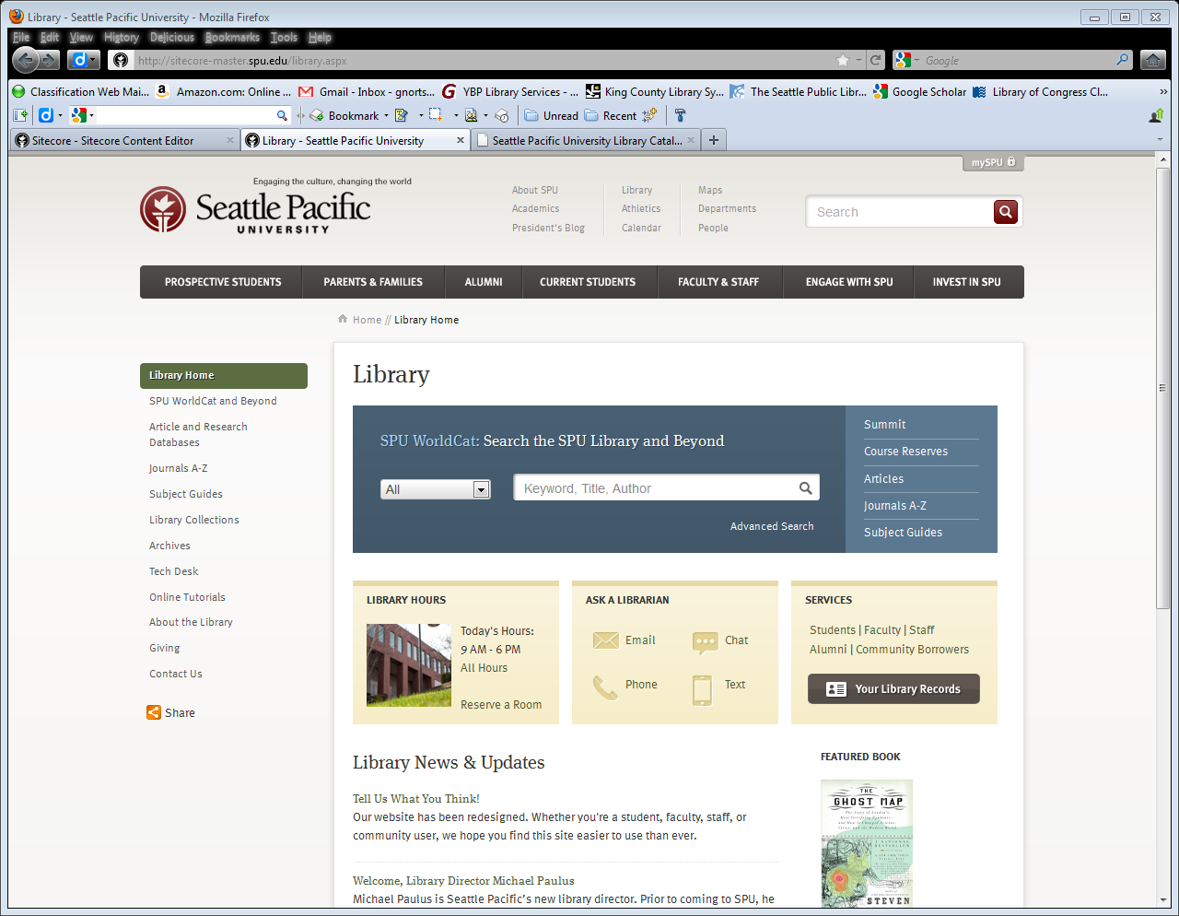
- From the SPU page www.spu.edu click on the Library link at the top of the page
- From the main page of the library, click on the Subject Guides link

- Click on the Business and Economics link
- Click on the Books, DVDs, etc. link
- Click on the Work & Faith Collection link

To modify your search
- Click on the blue Modify Search button found near the top of the page
- Select Graduate/Faculty Study Room from “Location” drop-down menu
- Add one or two keywords in the search box, or change the “Search and Sort” options
- Click Submit
- To find out more information about a title, click on any of the hyperlinked titles

Here is a link to the collection sorted by title
http://deborah.spu.edu/search/X?SEARCH=**&l=&m=&b=gra++&SORT=A&Da=&Db=&submit=Submit

Here is a link to the collection sorted by date
http://deborah.spu.edu/search/X?SEARCH=**&l=&m=&b=gra++&SORT=D&Da=&Db=&submit=Submit

