Work & Faith Collection
Library Catalog Search Steps

- From the SPU page http://www.spu.edu/, click on the Library link at the top of the page
- From the main page of the library, click on SPU WorldCat and Beyond link (see picture below)
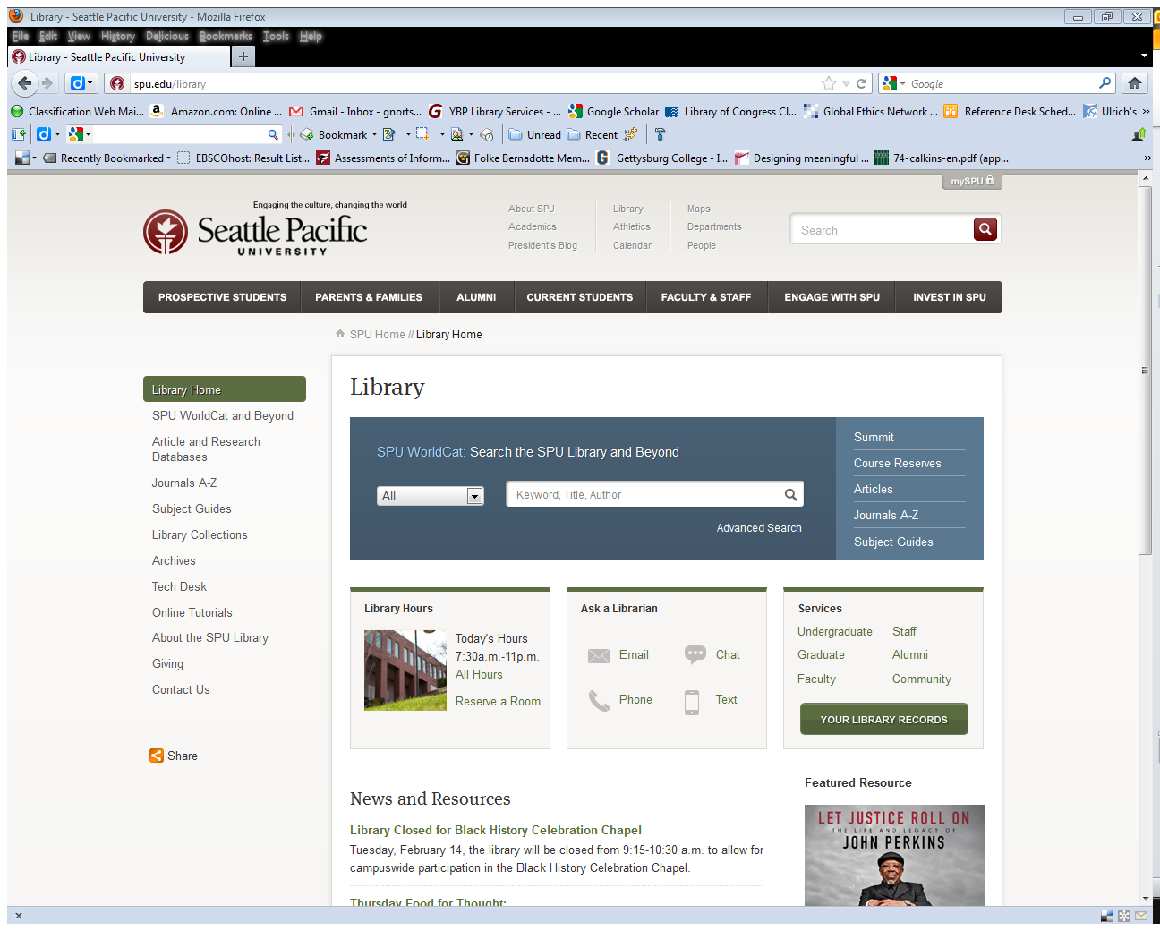

- On the “SPU WorldCat and Beyond” page, click on the Search Classic Catalog link
- On the “Search Classic Catalog” page, click on the SEARCH button at the bottom of the page
- On the “SPU Library Catalog” page, click on the Keyword link
- Type ** into the search box. This will result in a list of all the titles held in this collection.
- From the “Location” drop down menu, select the Graduate/Faculty Study Room option
- Click the Submit button
- To find out more information about a title, click on any of the hyperlinked titles

To modify your search
- Click on the blue Modify Search button found near the top of the page
- Select Graduate/Faculty Study Room from “Location” drop-down menu
- Add one or two keywords in the search box, or change the “Search and Sort” options
- Click Submit
- To find out more information about a title, click on any of the hyperlinked titles

Here is a link to the collection sorted by title
http://deborah.spu.edu/search/X?SEARCH=**&l=&m=&b=gra++&SORT=A&Da=&Db=&submit=Submit

Here is a link to the collection sorted by date
http://deborah.spu.edu/search/X?SEARCH=**&l=&m=&b=gra++&SORT=D&Da=&Db=&submit=Submit

