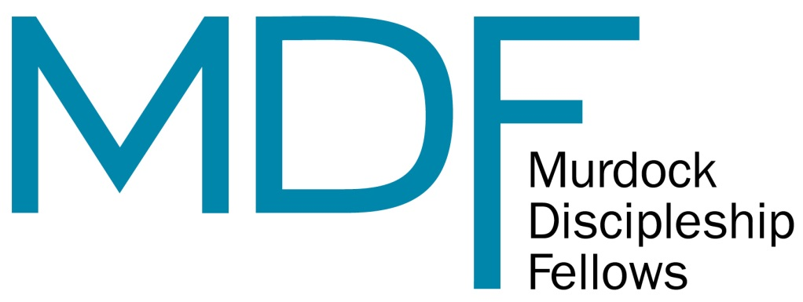

The Murdock Discipleship Fellows (MDF) program, sponsored by Seattle Pacific Seminary and the Center for Biblical and Theological Education, provides first-year seminarians an opportunity to receive valuable mentorship, training, and experience in discipleship ministries as a paid intern, while also having opportunity to invest in their own process of vocational discernment.

Each academic year, four first-year Seattle Pacific Seminary students (ages 22–27) will be selected for the MDF program. Fellows organize and lead undergraduate small groups and will train and mentor upperclassmen to lead additional discipleship groups. Fellows will also be involved in intentional exercises on vocational discernment, including readings, written reflections, and one-on-one mentoring, and will engage in thoughtful discussions with senior leaders from both within and outside the University.

MDF Program Distinctives
Young-adult seminarians with a passion for ministering to college students should apply for this program. As a Fellow, you will receive:
- Training and leadership experiences related to developing a practical theology of discipleship ministry
- The opportunity to be involved in ministry while in the midst of seminary education, and to develop skills in pastoral care, discipleship, mentoring, leadership development, and program design, implementation, and evaluation
- The opportunity to dialogue with senior leaders from within SPU and the extended SPU network about the nature of vocation and calling
- One-on-one mentoring with specific emphases on the discernment of one’s gifts, passions, and calling in ministry
- An invitation to the annual Murdock “Vision & Call” retreat with other program participants from across the Pacific Northwest

Funded in part by a “Vision & Call” grant from the M.J. Murdock Charitable Trust, Fellows will serve 15-20 hours per week for a 9 month appointment (September 1 through June 1), and will receive $600/month in addition to full tuition scholarships for THEO 6001 “Christian Formation in Discipleship” and THEO 6002 “Christian Formation in Mission” classes (a total of 4 credits). Stipend payments are made 3 times per quarter at the beginning of the month. Federal taxes are withheld.

To be successful, the person in this position must possess the following attributes:

- The desire to: Grow spiritually in relationship with Jesus
Help others grow spiritually in Jesus

- The ability to: Establish and maintain healthy relationships
Lead with a servant attitude
Coordinate various events and activities
Communicate effectively
Be attentive to administrative details

- Stability and maturity: Emotionally, psychologically, and spiritually

APPLY NOW
Who Should Apply? | Incoming first-year seminarians between the ages of 22-27 as of September 1, 2014, who have been approved for admission to a degree program at Seattle Pacific Seminary, and who are able to take 9 credits per quarter while participating in the MDF program.
Why Should I Apply? | Fellows receive financial benefit, valuable ministry experience, intentional mentoring, and opportunity for vocational discernment.
When Should I Apply? | Completed applications for a given academic year should be submitted by March 1st. Interviews will be conducted in the two weeks following the application deadline, and applicants will be notified in writing either way by mid-March. Selected MDFs will serve from September 1, 2014 – June 1, 2015

APPLICATION INSTRUCTIONS:
Applications for the 2014-2015 MDF cohort are due by 5 p.m. on March 1, 2014. Complete packets include:
- Completed MDF application form
- 2 completed reference forms (1 personal and 1 from a pastor, professor, or employer. Forms should be submitted directly by the reference to the MDF Committee via one of the methods noted below)

Submit printed application to:

Murdock Discipleship Fellows Committee
c/o Kelsey Rorem
3307 3rd Avenue West, Suite 204
Seattle, WA 98119

Forms may also be submitted via email to cbte@spu.edu.

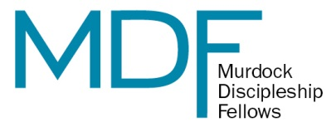

2014-2015 Application

Answer all questions below to the best of your ability. Items that do not apply should be noted with an “n/a” in the appropriate field. Use the keyboard arrows to navigate through the fields. All information is kept in strict confidence. Prior admission to one of the following master’s programs is required: Master of Divinity or Master of Arts in Theology.

NAME: Last, First Middle Initial.
_______________________________________________________________________________________
^{Last, First, Middle Initial}

ADDRESS: Street / P.O. Box
_______________________________________________________________________________________
^{Street / P.O. Box}

City, State. Zip
_______________________________________________________________________________________
^{City, State, Zip}

PHONE: Day; Evening
_______________________________________________________________________________________
^{Day, Evening}

E-MAIL: E-mail address
_______________________________________________________________________________________

DATE OF BIRTH: DATE OF BIRTH (MM/DD/YYYY)
____________________________________________________

SPU STUDENT ID NUMBER: SPU STUDENT ID NUMBER
_______________________________________________________

PROFESSIONAL PREPARATION
Please begin with the most recent institution you have attended.

College/University/Seminary: College/University/Seminary
Dates of Attendance: Dates of Attendance Credits Earned: Credits Earned
Degree Awarded: Degree Awarded

College/University/Seminary: College/University/Seminary
Dates of Attendance: Dates of Attendance Credits Earned: Credits Earned
Degree Awarded: Degree Awarded

College/University/Seminary: College/University/Seminary
Dates of Attendance: Dates of Attendance Credits Earned: Credits Earned
Degree Awarded: Degree Awarded

EMPLOYMENT EXPERIENCE
Please begin with the most recent employer.

School/Company: School/Company
Address: Address
Supervisor: Supervisor Phone: Phone
Your Title: Your Title Dates Worked: Dates Worked
Your Duties: Your Duties

School/Company: School/Company
Address: Address
Supervisor: Supervisor Phone: Phone
Your Title: Your Title Dates Worked: Dates Worked
Your Duties: Your Duties

School/Company: School/Company
Address: Address
Supervisor: Supervisor Phone: Phone
Your Title: Your Title Dates Worked: Dates Worked
Your Duties: Your Duties

SUPPLEMENTAL INFORMATION

List any health problems that might affect your job performance: Health Problems

Do you have any commitments or responsibilities that would prevent you from being at work for the required 15-20 hours per week? NO YES If yes, please explain: Please Explain

Have you been formally admitted to Seattle Pacific Seminary as a student? NO YES

What degree are you pursuing? Degree

List any relevant prior work or volunteer experience: Volunteer Experience

After reading the STATEMENT OF FAITH OF SEATTLE PACIFIC UNIVERSITY (pages 5-6), please respond to one of the following:

“I have read the STATEMENT OF FAITH OF SEATTLE PACIFIC UNIVERSITY, and am in agreement.”

“I have read the STATEMENT OF FAITH OF SEATTLE PACIFIC UNIVERSITY, and am in agreement except as noted below.”
In agreement except…
ESSAY QUESTIONS
(Please respond to the following questions with up to 500 words for each section.)

For Sections 1 & 2, we can utilize your SPS application in lieu of asking you to write new material. However, if for any reason you do not wish your admissions material to be used for the MDF vetting process you will need to submit new essays for all three questions. Please indicate your choice by selecting the appropriate box below.
The MDF selection committee may utilize the “Personal Statement” from my SPS admissions application in lieu of Sections 1 & 2 of the MDF Essay Questions. NO YES
* If no, please be sure to submit Sections 1, 2, & 3 with your MDF application.
* If yes, you only need to submit Section 3 with your MDF application.

***

Section 1 – Christian Spiritual Formation
- Describe your journey to faith in Christ.
- Describe your current pursuit of acts of piety and acts of service, including ways they are shaping your life.
- State how you intend to build and maintain a pattern of self-care and self-awareness for your emotional, spiritual and psychological health as you move through seminary.

Section 2 – Call to Ministry
- Describe your sense of call to seminary and/or ministry and how that call has been affirmed by the church.
- Give a sense of your gifts and graces for ministry as evidenced by past leadership or ministry experiences.

Section 3 – Why the Murdock Discipleship Fellows?
- A large part of the MDF experience will involve discipling and mentoring college students. What has been your past ministry experience with this age group, and explain what you see as some of the key spiritual issues for the demographic.
- Explain why you are interested in applying to be an MDF, giving specific reasons as to its potential impact on your seminary education experience.

***

Please read the following statement, and sign/date where indicated:
“I UNDERSTAND THAT:
(1) Falsification of information on this application may result in dismissal from either the candidacy or the fellowship,
(2) Employment is subject to satisfactory references and job verification, and
(3) Remuneration for the Murdock Discipleship Fellowship is subject to U.S. government income tax stipulations.”

Applicant Signature: Applicant Signature
Date: Date
Statement of Faith for Seattle Pacific University

Faith and Mission.

At Seattle Pacific University, we seek to ground everything we do on the transforming gospel of Jesus Christ. Such a claim is both personal, a commitment by each member of our community, and institutional, a corporate aspiration that has guided this institution from its founding. Even while we celebrate the rich diversity of the Church throughout the world, we anchor our faith on the person of Jesus Christ, the authority of Holy Scripture, and the tradition of the Christian Church throughout history.

1. We are Historically Orthodox.
We affirm the historic Christian faith, as attested in the divinely inspired and authoritative Scriptures of the Old and New Testaments, and as summarized, for example, in the Apostles’ and Nicene Creeds. We affirm that God is triune, and that the three divine Persons — the Father, the Son, and the Holy Spirit — are coequal, coessential, and coeternal. We affirm that by the grace and power of God the universe was brought into being, is continually sustained and governed, and will ultimately be brought to its promised consummation. We affirm, further, that we human beings are created by God in God’s own image to be stewards of creation, and that we are called to love God with all our heart, soul, mind and strength, and to love others as ourselves. In these divinely appointed tasks we have failed, so that we are now subject to judgment and death. Yet we rejoice that God’s grace is available to us through the life, death, and resurrection of Jesus Christ; and that through faith in Christ we are delivered from sin and death and empowered by the Holy Spirit for lives of joyful obedience to the Father. Finally, we respond to the Spirit’s call to participate in Christ’s body, the church; to embrace Christ’s mission to the world; and to live in the hope and assurance that Christ’s return will bring to completion God’s saving work.

2. We are Clearly Evangelical.
We stand within the broad evangelical tradition of Christianity and, as such, we joyfully accept the task of proclaiming the evangel — God’s good news — to the world. We understand this to mean that Jesus Christ is the Lord and Savior of the world and that he alone can liberate broken and fallen human beings from sin and death. We lift high the authority of holy scripture as divinely inspired, embraced by the church as central to our understanding and witness. We affirm that the Holy Spirit works in human hearts to kindle faith in Jesus Christ, to restore people to a right relationship with God and each other, and to begin transforming people into the likeness of Christ. And we believe the gospel promise that light, health, wholeness, and peace are abundantly available to everyone who asks. Yet we also believe that we are called to practice what we preach: first, by cultivating vital Christian piety; and second, by engaging the surrounding culture through public testimony and loving service.

3. We are Distinctively Wesleyan.
Standing within the Wesleyan holiness branch of historic and evangelical Christianity, and recognizing the Free Methodist Church as our founding denomination, Seattle Pacific University is informed by the theological legacy of John and Charles Wesley. We share their conviction that God’s saving purpose is the renewal of human hearts and lives in true holiness through the transforming work of the Holy Spirit. We are shaped by their emphasis on the importance of the human response to the Spirit’s renewing work, including the vital role of the spiritual disciplines and practices — such as prayer, meditation, worship, Scripture study, charitable giving, public witness to Christ’s saving love, and service to those in need — all of which serve as means of God’s grace. Above all, we embrace the Wesleys’ hope that God’s transforming love is offered to all persons, addresses all areas of life, and will not rest content until it has redeemed the whole creation.

4. We are Genuinely Ecumenical.
As heirs of John Wesley’s catholic-spirited Christianity, we seek to gather persons from many theological and ecclesial traditions who have experienced the transforming power of Jesus Christ. We believe that theological diversity, when grounded in historic orthodoxy and a common and vital faith in Christ, enriches learning and bears witness to our Lord’s call for unity within the church. We are also well aware of other dividing walls that separate people from one another, walls that Christ desires to break down — walls of gender, race, ethnicity, nationality, language, and class. We believe that Christ calls us to value diversity and to seek ways for all persons in our university community to grow in their individual giftedness and to contribute in meaningful ways to our common life and work. Thus, in all of our diversity, we are centered in Christ, and called by him to shape, model, and participate together in grace-filled community.
Therefore, we commit ourselves to this faith, and to these shaping influences that define our community of faith, and we pledge ourselves, with humility and conviction, to live as best we know how in loving relationship with Jesus Christ and in faithful service to others. This we believe to be the defining center of our lives and the guiding aspiration of our life in community at Seattle Pacific University.

