SPU Music Department presents
Dr. Gabrielius Alekna masterclass
featuring SPU piano students
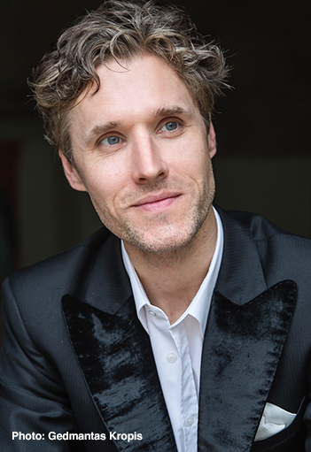
Described by Daniel Barenboim as “a highly gifted pianist and musician,” pianist Gabrielius Alekna has built a prolific performance and recording career bridging the cultures of his birth country of Lithuania and his present home of the United States. After earning over one dozen top prizes in international competition early in his career—including 2nd Prize at the Beethoven International Piano Competition in Vienna—he has established himself as a soloist of international renown. Performances include with the Vienna Radio Symphony Orchestra (RSO Wien), Juilliard Orchestra, the New Amsterdam and Adelphi Symphony Orchestras (New York), Bilkent Symphony Orchestra (Turkey), the Belarus State Symphony Orchestra (Minsk), and with nearly every major orchestra and ensemble in Lithuania.
Alekna’s distinctive programs and prolific piano repertoire have taken him to fifteen countries, including solo recitals in Carnegie Hall, Washington, D.C.’s National Gallery, the United Nations headquarters in Geneva, both Vienna’s Musikverein and Bösendorfer Saal, and Finland’s Temppeliaukion kirkko. Broadcast recordings of his performances can be found on BBC, WQXR, WWFM, CBC Music, Österreich 1, Bulgarian National Radio, and numerous EuroClassic radio programs.
An avid studio musician, Alekna’s discography prominently features Lithuanian contemporary and 20th-Century modernist piano repertoire, reflecting his strong affinity for the country’s remarkable avant-garde composers both past and present. In 2024, Alekna released the singular Lithuanian American composer Vytautas Bacevičius’ Piano Concerti Nos. 1 and 2, completing the cycle after his 2015 recordings of Nos. 3 and 4—all on the Naxos label. For Toccata Classics, he has released two volumes in an ongoing series of the same composer’s solo piano works.
Born and raised in Vilnius, Gabrielius received a Doctor of Musical Arts, Master’s and a Bachelor’s degrees from The Juilliard School, under the tutelage of Jerome Lowenthal. Before attending Juilliard, he studied in Lithuania’s premier arts institutions, the National M. K. Čiurlionis School for the Arts and the Lithuanian Academy of Music and Theatre. He is a former faculty member at CUNY Brooklyn College and serves as substitute faculty at The Juilliard School. In 2023, he joined the Recording Academy / Grammys as a voting member. Gabrielius lives with his family in New York City.

Thursday at 11:00 a.m., November 6, 2025

Performance Hall at Nickerson Studios
340 W Nickerson St, Seattle, WA 98119

