Build-Beloved Executive Summary
The Issue
Housing crisis and environmental pollution are two of the most soaring issues in the global landscape as of current. Rapid urbanization and immigration exacerbate housing insecurity, leading to poverty and increasing unemployment, thus leaving millions of families vulnerable to homelessness and poor living conditions. At the same time, improper waste management threatens the ecosystem that sustains our life, causing a proliferation of large-scale plastic pollution and worsening climate change.
The Solution
Against this backdrop, Build-Beloved has developed a holistic and radical business model in response to these pressing challenges through leveraging the power of ecotourism. Our journey starts from the beautiful Jalapa of Guatemala. The ecotourism packages aim to engage travelers in activities that promote environmental stewardship like assembling plastic bottles and household waste to create “eco-bricks”, which will then be utilized to build homes for the needed. After being prepared, these eco-bricks will be stabilized between columns and beams and continuously reinforced with construction mesh, then finalized by cement plastering. Houses built from eco-bricks have been proven to be resilient, earthquake safe, and have excellent insulation, which makes them a perfect ecological and budget efficient alternative for traditional building materials. Additionally, fostering community involvement is a cornerstone of our approach – we anticipate having the local to participate in the collection and donation of plastic bottles and other waste along with the tourists. This will both nurture a sense of pride and ownership within the community we serve. Build-Beloved’s plan is purposeful and community-oriented: we provide efficient and sustainable housing solutions and simultaneously mitigate pollution caused by plastic waste, while bringing meaningful and valuable adventures to mindful travelers. Success is measured by the number of bottles we collect and the number of houses we can build out of those, as well as the quantity of participants we have for each trip.
Competitive Advantage
Build-Beloved's competitive advantage lies in its holistic approach to addressing Guatemala's housing crisis and waste pollution through ecotourism. Unlike other organizations, Build-Beloved not only offers housing solutions but also actively involves tourists in hands-on participation, fostering a deeper connection to the cause and providing unique cultural experiences. Ultimately, Build-Beloved's comprehensive approach, coupled with its commitment to environmental sustainability and community empowerment, positions it as a catalyst in tackling interconnected social and environmental challenges in Guatemala.
Financial Viability
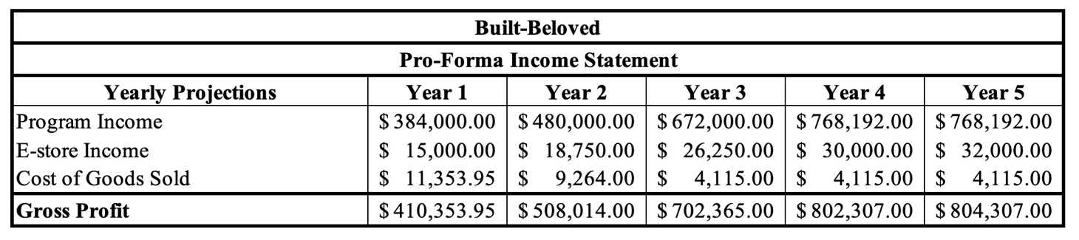
Vision Statement
Build-Beloved envisions a future where every family in Guatemala has access to safe and sustainable housing, while fostering environmental stewardship and community prosperity.
Strategy Statement
Build-Beloved will provide sufficient shelters for Guatemalan’s families in need through sustainable and ecological building materials made of water bottles and plastic waste, while operating in the ecotourism segment to both fund our projects and raise awareness. Through our mindful traveling packages and E-business, we work towards optimizing ecotourism, sustainable and ethical construction practices, and community empowerment initiatives to address both housing shortage and waterway pollution in Guatemala.

