Creating Accessible Microsoft Word 2007/2010 Documents

Headings
Create a uniform heading structure through use of styles in word. This allows screen readers to navigate a document, and improves accessibility for everyone.

Adding and Editing Headings
Headings can be created using the styles toolbar. This is illustrated below:
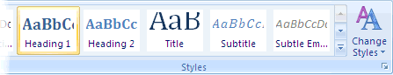

- Select the text and click on the appropriate style. For example, select “Heading 1.”
- Headings 1, 2, or 3 can also be assigned using CTRL + ALT + 1, 2, or 3 on the keyboard.

Alternative text for Images
Images can be given appropriate alternative text in World. This alternative text is read by a screen reader in a Word file and should remain intact when exporting to HTML or PDF. This is illustrated below.
- In Word 2007.
  - Right-click on the image and select “size.” A dialog box will appear.
  - Select the “Alt Text tab,” and replace the filename with appropriate alternative text.
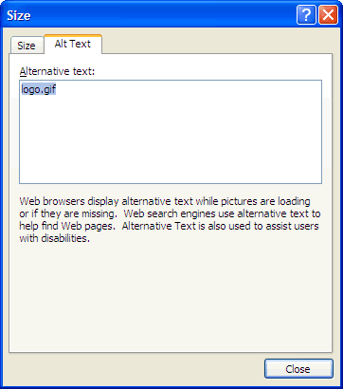

- In Word 2010
  - Right-click on the image and select “Format Picture.” A dialog box will appear.
  - Select the Alt Text tab on the sidebar. Enter appropriate alt text to the “Description field,” not the Title field.
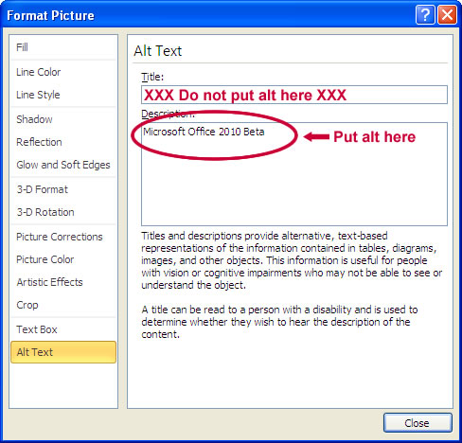

Columns
When creating columns, always use true columns, not columns created by hand with the Tab key.

Creating Columns
- Select “Page Layout” on the Ribbon.
- Select “Columns” in the Page Setup group.
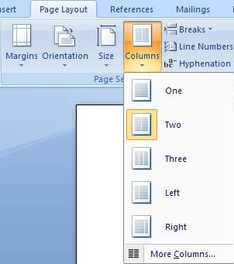

Data Tables
Use the “Insert Table command” to create tables, not by hand with spaces or the Tab key.

Links
Word automatically creates a hyperlink when a user pastes a full URL onto a page. These may not make sense to screen reader users, so more information is needed.

Editing Hyperlinks
- Select a hyperlink, right click, and select “Edit Hyperlink” or CTRL +K.
- Change the URL in the “Text to Display field” to a more meaningful description. 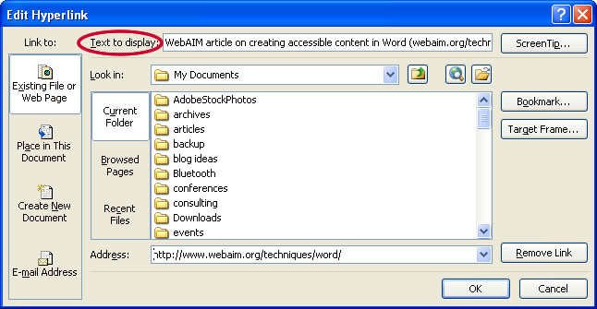

Lists
Use true numbered and bulleted lists to emphasize a point or a sequence of steps.

Creating Lists
- Select “Page Layout” on the Ribbon (The header at the top of the Microsoft Word Document Page).
- Select “Bullets and Numbering.”

Other Important Principles
- Ensure that font size is sufficient, around 12 points.
- Provide sufficient contrast.
- Don’t use color as the only way to convey content.
- Provide a table of contents, especially for long documents.
- Use simple language.

Word 2010 Accessibility Checker
- Select File > Info > Check for Issues > Check Accessibility.
- The checker presents accessibility errors, warnings, and tips on how to repair the errors.

Creating Accessible Microsoft PowerPoint Presentations

Outline and Notes Panel
- PowerPoint contains two panels that can be used to enhance accessibility: the outline panel and the notes panel.

The Outline Panel
- The outline panel contains a text outline of the content that appears in your slides.
- Reviewing this panel can help ensure the content on the slides is logically sequenced, that slide titles are unique and meaningful, and that reading order is appropriate for any user.

The Notes Panel
- The notes panel allows the speaker to add notes and information that will not appear on the slides.
- Placing image or chart description in this area should be avoided. This information may not be accessed by a screen reader, so use with caution.

Other Important Principles
- Ensure that font size is sufficient. If your presentation will be viewed on a projector, font size may need to be even larger.
- Provide sufficient contrast. If your presentation will be viewed on a projector, sometimes the contrast needs to be even more pronounced.
- Do not use color as the only way to convey content.
- Avoid automatic slide transitions.
- Use simple slide transitions when possible.
- Use simple language.
- Check reading order of text boxes that are not part of the native slide layout. They are usually the last thing read by a screen reader.
- If you have embedded a video, ensure that the video is captioned, and that the player controls are accessible.
- If you have embedded audio, include a transcript.
- If your slides contain animations, ensure that they are brief and do not distract from the most important content on the page.

PDF Conversion in Microsoft Word 2007/2010 Documents

Converting to PDF
To produce accessible PDF files for the web, the following requirements must be met:
- The file must meet accessibility standards by providing alternative text for images, proper headings, appropriate link text, etc.
- The file must be exported correctly. If a file is created by printing to PDF, it will not be correctly tagged.
- Office 2007 users must have either Acrobat or the Microsoft PDF add-in installed. Office 2010 users can create tagged PDF files natively or with the Adobe add-in.
The following instructions can also be used to convert PowerPoint files to PDF.

Word 2007

Adobe Add-in
The Adobe Add-in, also called PDFMaker, is the best choice to create high-quality tagged PDF files.
- To export a PDF, click on the Office button, hover over “Save As,” and select “Adobe PDF (or use shortcut Alt+F, F, A).

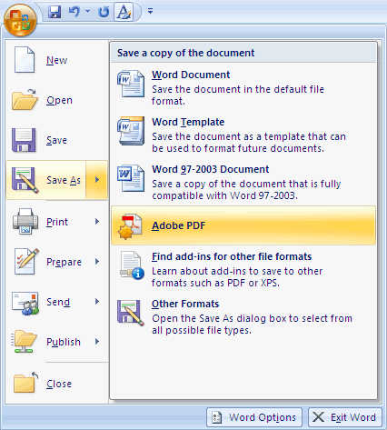

- Or you can select “Create PDF” from the Acrobat ribbon. A dialog box will appear.
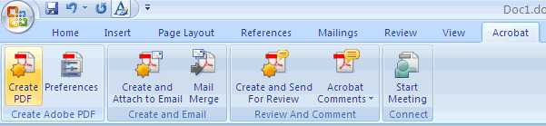

- The program should create a tagged PDF file by default. If not, select “Adobe PDF Conversion Options” and select the “Create Accessible (Tagged) PDF file” option.

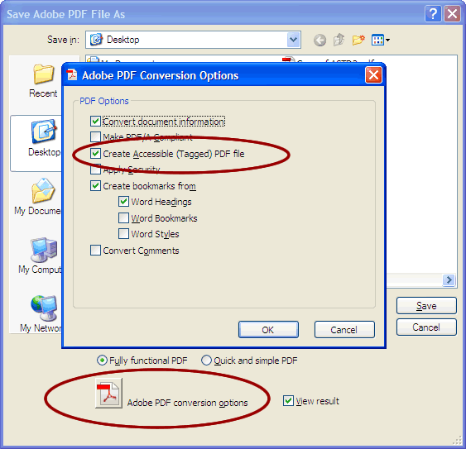

Microsoft Add-in
Word 2007 offers a free “Save as PDF Add-in” that allows you to create tagged PDF files without installing Acrobat.
- Click on the Office Button, hover over “Save as,” and select “Adobe PDF (or use shortcut Alt+F, F, P).
- Before saving, select “Options” and ensure that the “Document structure tags for accessibility” option is selected

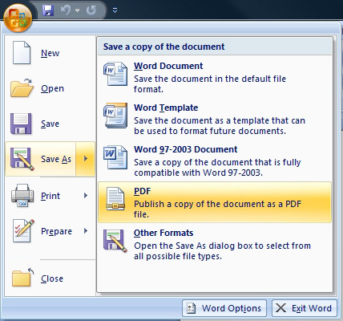

Word 2010

Adobe Add-in
Please note that the Acrobat add-in is only available to users who have “Acrobat X installed and have the “32-bit version” of Office 2010.
- To export a PDF, select “Create PDF” from the Acrobat ribbon.

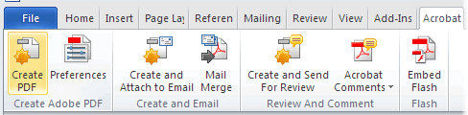

- Or you can select File > “Save as Adobe PDF.” A dialog box will appear.
- The program should create a tagged PDF file by default.
- If not, select “preferences” from the Acrobat ribbon and ensure that “Enable Accessibility and Reflow with tagged Adobe PDF” is selected.
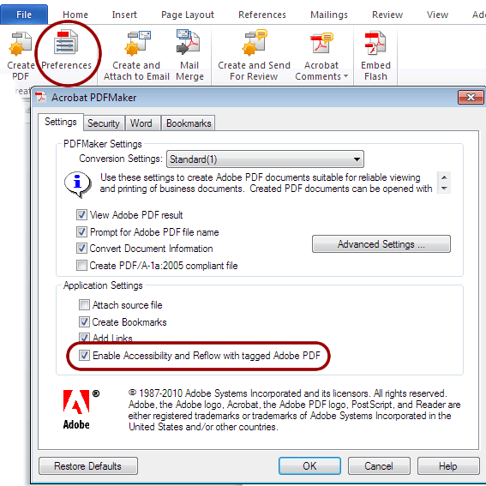

Saving PDF Natively
Tagged PDF files can still be created without installing Acrobat.
- Select File > “Save as.”
- Under “Save as Type,” select PDF.
- Before saving, select “Options” and ensure that the “Document structure tags for accessibility option” is selected.
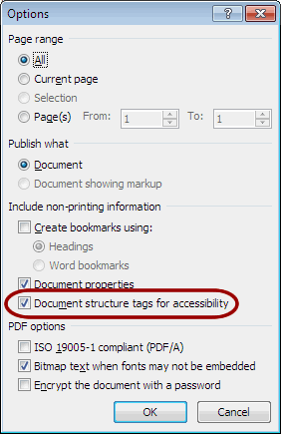

Creating Accessible PDF Documents in Adobe Acrobat X

Tags Pane
PDF tags provide accessibility information to screen readers. They should not impact the look of the PDF. To view and edit tags, do the following.
- Select “View” > “Show/Hide” > “Navigation Panes” > “Tags”
- Select the “Options Menu” > “Highlight Content”. This allows you to see what content is associated with a tag.
- In the “Tags” panel, expand <tags> and <sect> to view and navigate your list of tags.
- Navigate through the tags using the up/down arrow keys, and expand and collapse tags with the left/right arrow keys.
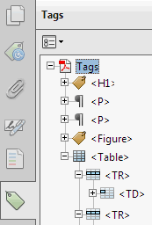

Find Tag From Selection
- Click the “Select Tool icon” and select a portion of text, an image, or a table.
- Select the “Options menu” at the top of the Tags panel and then select “Find Tag From Selection.” The appropriate tag will be highlighted in the tags panel.

Modifying Tags
- Right-click the tag you want to change and select “Properties,” and then the “Tag” tab.
- Selecting the appropriate new tag type from the dropdown list labeled “Type.”
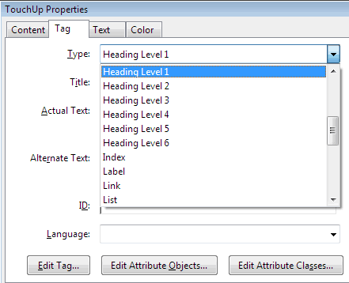

Tagging an Untagged Document
- To add tags to an untagged document, choose “Tools” from the right-hand menu.
- Select “Accessibility” > “Add Tags to Document.”

TouchUP Reading Order
The TouchUp Reading Order tool allows a user to quickly add and edit PDF tags and view the reading order of elements on the page.

TouchUp Reading Order Tool
- From the right-hand menu, select “Tools.”
- Then select “Accessibility” > “TouchUp Reading Order.” If the Accessibility option is not listed, use the “Options” button to check “Accessibility” on the menu.
- When selected, the view on the screen changes. All of the content is enclosed in numbered boxes. Each of these boxes represents a tag and the number corresponds with the reading order in the “Order panel.”
- Within the “TouchUp Reading Order” window you will notice a group of buttons with the names of several common tags. You can use these buttons to assign tags to selected text or objects.
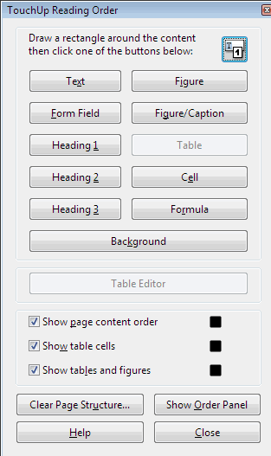

Adding/Changing Tags
- To select content that needs editing, drag a box around an element using the “crosshairs cursor” or select everything within a box by clicking on the number in the top-left corner.
- Once you have selected a new element, you can assign some of the most common tags to that element by clicking on one of the buttons (e.g., “Heading 1”). Acrobat will place the selected content in the appropriate tag.
- Assign alternate text to images by right-clicking on the image and choosing “Edit Alternate Text.”

Order Panel
The order panel allows you to change the reading order of the page content so it matches the visual reading order.
- To open the Order panel, select “Show Order Panel” in the “TouchUp Reading Order” tool.
- To change the reading order of an element, click and drag the tag to the location that reflects the correct reading order.
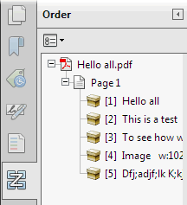

Alternative Text
When an image is tagged as a figure the alternative text appears over the top of the image.
- To add or change text, “Right click” on the image, select “Edit Alternate Text.”
- Enter the appropriate alternative text in the dialogue box.

Table Inspector
The Table Inspector allows you to easily identify and assign scope to table headers.
- With the “TouchUp Reading Order” tool open, select a table and then select “Table Inspector.”
- Right click on a selected cell and choose “Table Cell Properties.” A dialogue box will appear.
- If the selected cells(s) needs to be tagged as a header, select the “Header Cell” option and assign a scope of either “Row” or “Column.”

Artifacts
Artifacts are elements that are ignored by a screen reader. Important text should never be labeled as an artifact.
- With the “TouchUp Reading Order” tool open, select an element you wish to change to an artifact and press the background button. Or right click on an item in the “Tags” panel, and select “Change Tag to Artifact.”
- To search for artifacts, go to the “Tags” panel and select “Options” > “Find.” Artifact is the default search option, so click “Find.”

